DAD 220

Ahmer Allauddin

Tanner Wale

9 May 2022

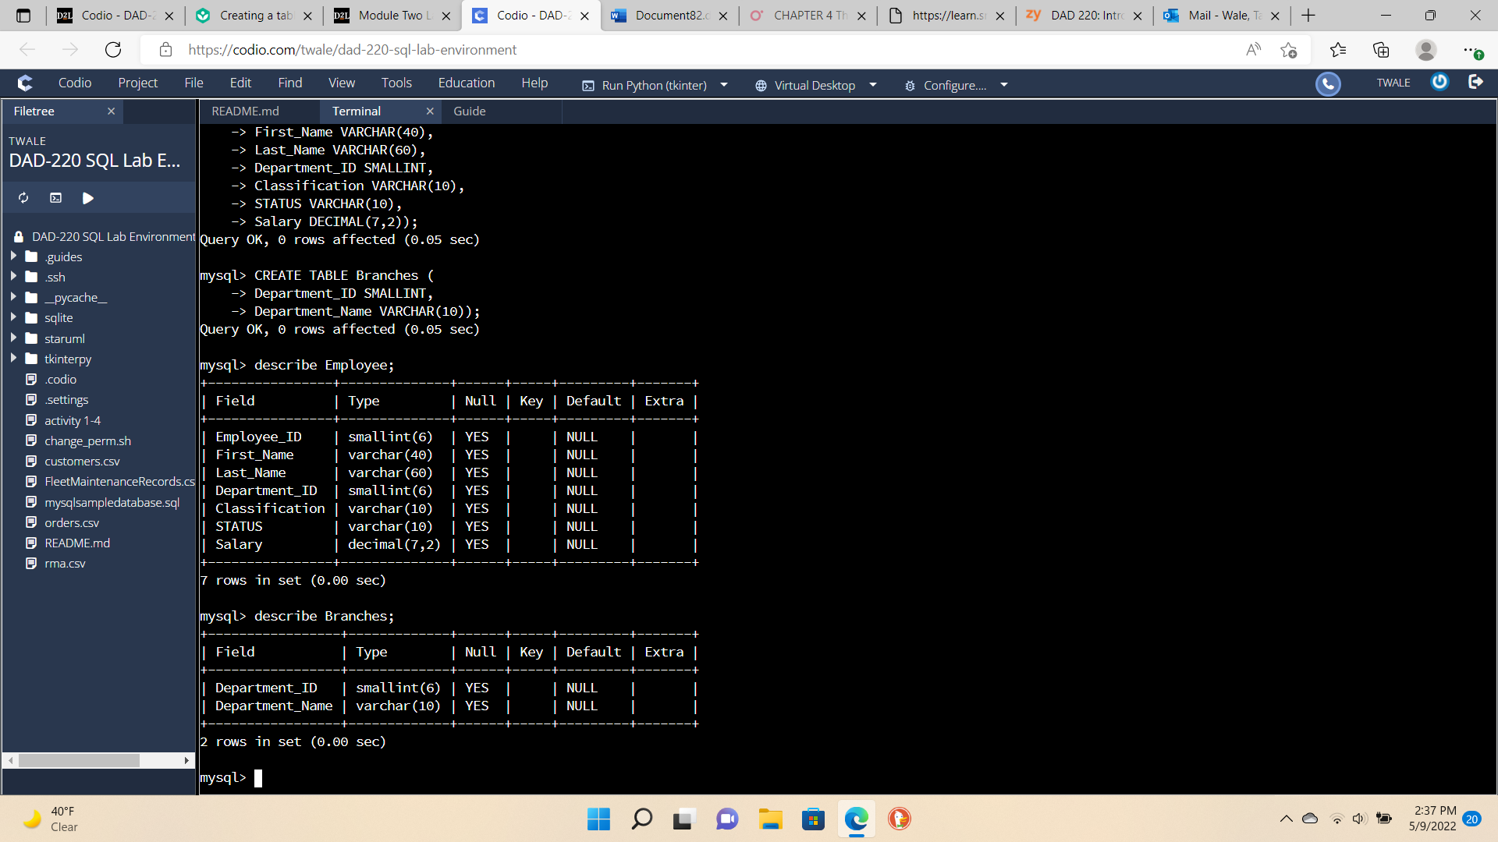

To connect to the database, we created in the last Lab 1-4 we use the command use Wale to connect to the specific database. To fill out the missing information of commands to create the Branches table, we need to add on the first line ‘CREATE TABLE Branches (‘ and Department_Name VARCHAR(10) because it will have a letter not numbers for the data type. To describe a table or in other words view the table we use the command describe Employee or describe Branches.

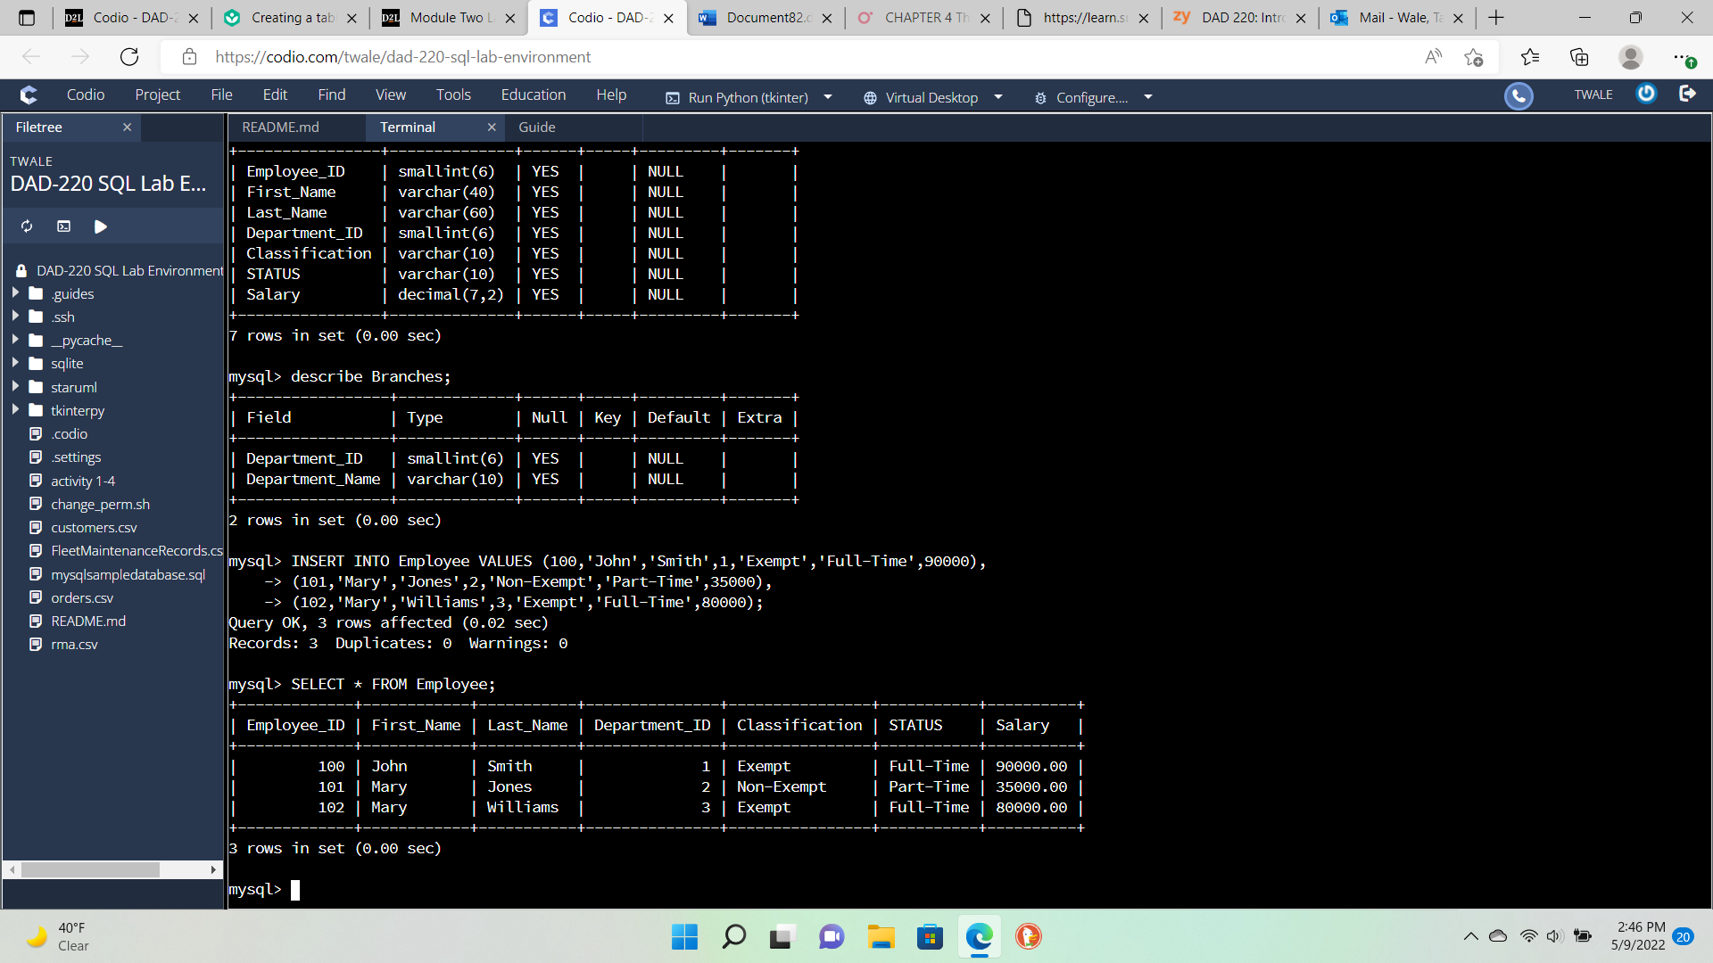

To insert values into the table Employee we need to use the command INSERT INTO Employee VALUES. Then add values in the parentheses with the right type of data in each column. To select the table from Employee we use the command SELECT * FROM Employee.

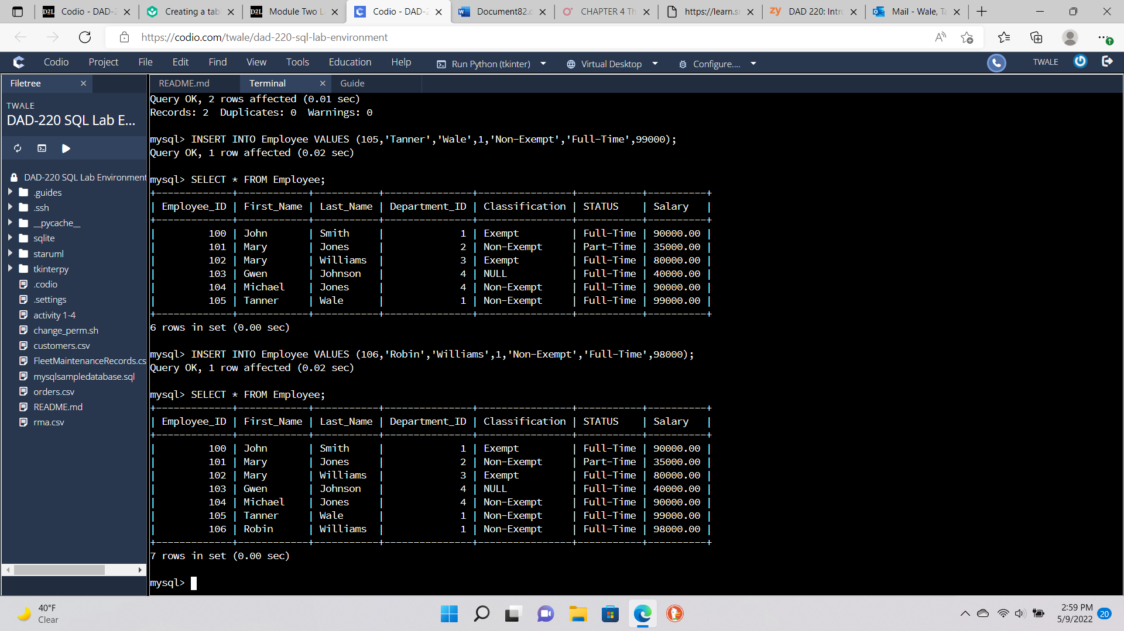

To implement our name into the table Tanner Wale we use the same command INSERT INTO Employee VALUES. Making sure to type data correctly in each column for data type purposes. We use the command SELECT * FROM Employee when we are done to select the table. The next person to implement is Robin Williams, which we first need to come up with an Employee_ID number 106. Then input his name with quotes for string type, Department_ID number is 1, and Classification is Non-Exempt, Status is next to input Full-Time, and finally the Salary of Robin WIlliams which is 98000.

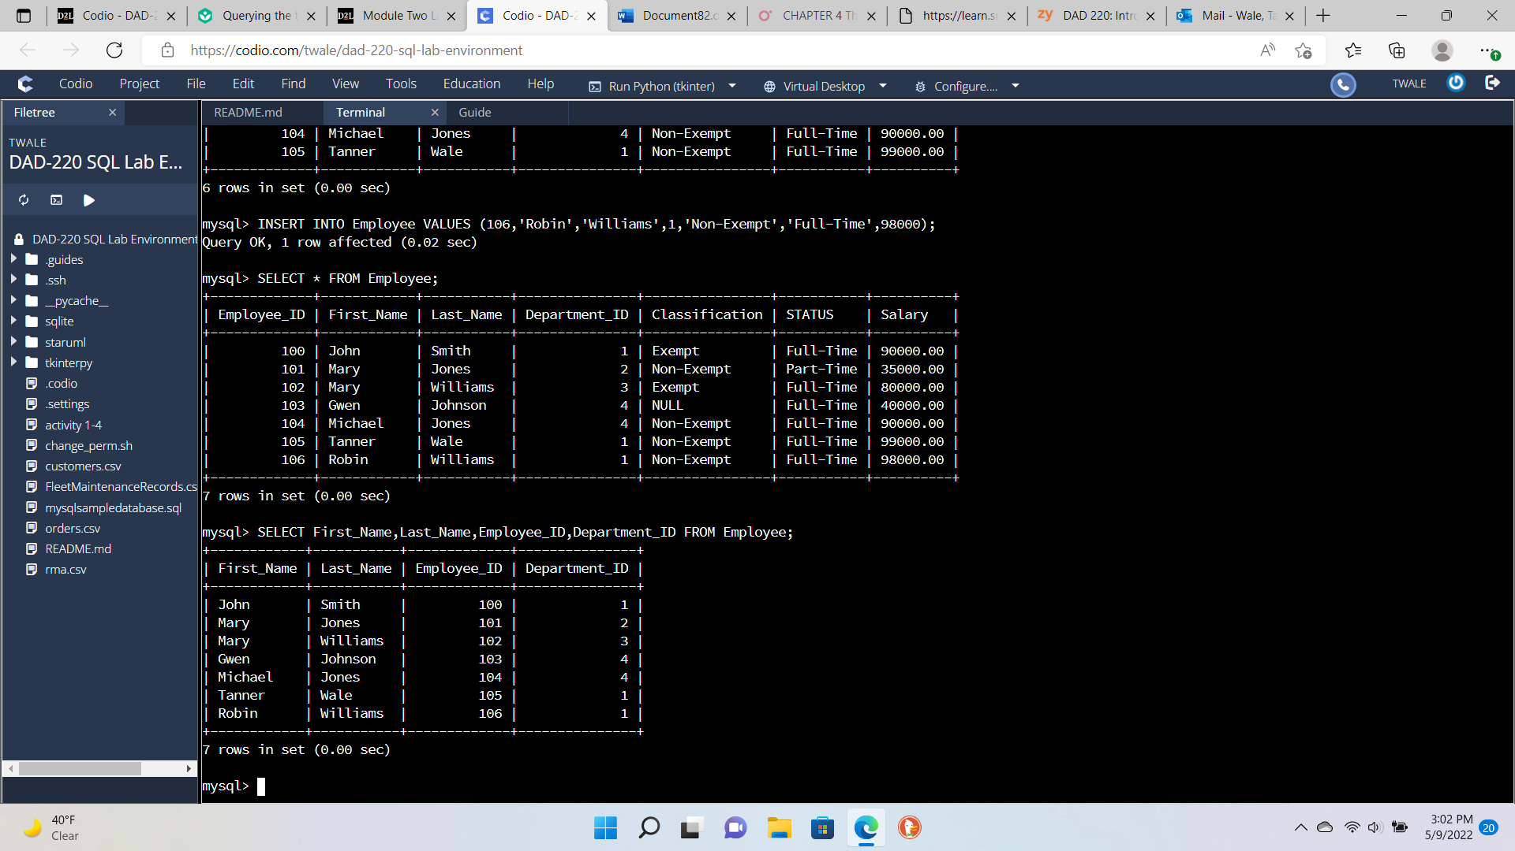

To select only certain attributes in the table Employee we use the command SELECT First_Name, Last_Name, Employee_ID, Department_ID FROM Employee. We are then prompted with only the attributes we selected with the prompt. As we cannot see the data for Classification, STATUS, and Salary.